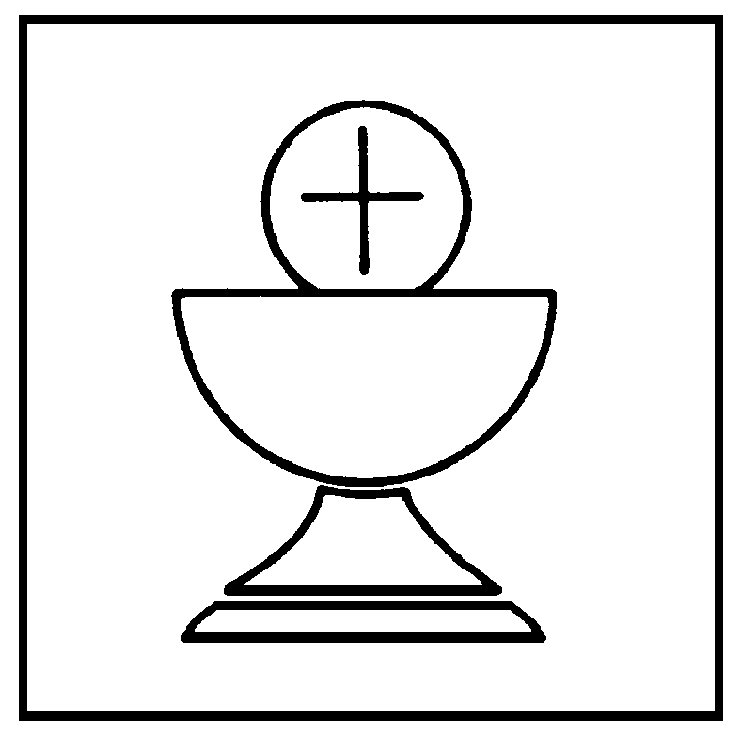
Holy Communion
Ordinary Time

In the name of the Father,
and of the Son, and of the Holy Spirit. Amen

The Lord be with you
All and also with you

Almighty God, to whom all hearts are open,
all desires known, and from whom no secrets are hidden:
cleanse the thoughts of our hearts
by the inspiration of your Holy Spirit,
that we may perfectly love you,
and worthily magnify your holy name;
through Christ our Lord. Amen

Prayers of Penitence
God so loved the world that he gave his only Son Jesus Christ
to save us from our sins, to be our advocate in heaven,
and to bring us to eternal life.

Let us confess our sins in penitence and faith,
firmly resolved to keep God's commandments
and to live in love and peace with all.

Almighty God, our heavenly Father,
we have sinned against you
and against our neighbour
in thought and word and deed,
through negligence, through weakness,
through our own deliberate fault.
We are truly sorry and repent of all our sins.
For the sake of your Son Jesus Christ,
who died for us, forgive us all that is past
and grant that we may serve you in newness of life
to the glory of your name. Amen

The president declares God’s forgiveness ...

Gloria in Excelsis
Glory to God in the highest,
and peace to his people on earth.

Lord God, heavenly King,
almighty God and Father,
we worship you, we give you thanks,
we praise you for your glory.

Lord Jesus Christ, only Son of the Father,
Lord God, Lamb of God,
you take away the sin of the world:
have mercy on us;
you are seated at the right hand of the Father:
receive our prayer.

For you alone are the Holy One,
you alone are the Lord,
you alone are the Most High, Jesus Christ,
with the Holy Spirit,
in the glory of God the Father. Amen

Bible Reading

Talk

Prayers of Intercession

Lord, in your mercy
hear our prayer

And at the end

Merciful Father,
accept these prayers for the sake of your Son,
our Saviour Jesus Christ. Amen

Profession of Faith

Let us affirm our common faith in Jesus Christ.

Do you believe and trust in God the Father,
source of all being and life,
the one for whom we exist?
I believe and trust in him

Do you believe and trust in God the Son,
who took our human nature,
died for us and rose again?
I believe and trust in him

Do you believe and trust in God the Holy Spirit,
who gives life to the people of God
and makes Christ known in the world?
I believe and trust in him

This is the faith of the Church.
This is our faith.
We believe and trust in one God,
Father, Son and Holy Spirit.

The Peace
We are the body of Christ.
In the one Spirit we were all baptized into one body.
Let us then pursue all that makes for peace
and builds up our common life.

The peace of the Lord be always with you
and also with you

Eucharistic Prayer E
The Lord is here
His Spirit is with us

Lift up your hearts
We lift them to the Lord

Let us give thanks to the Lord our God
It is right to give thanks and praise

Father, you made the world and love your creation.
You gave your Son Jesus Christ to be our Saviour.
His dying and rising have set us free from sin and death.
And so we gladly thank you,
with saints and angels praising you, and saying:

Holy, holy, holy Lord,
God of power and might,
heaven and earth are full of your glory.
Hosanna in the highest.
Blessed is he who comes in the name of the Lord.
Hosanna in the highest.

We praise and bless you, loving Father,
through Jesus Christ, our Lord;
and as we obey his command, send your Holy Spirit,
that broken bread and wine outpoured
may be for us the body and blood of your dear Son.

On the night before he died he had supper with his friends
and, taking bread, he praised you.
He broke the bread, gave it to them and said:
Take, eat; this is my body which is given for you;
do this in remembrance of me.

When supper was ended he took the cup of wine.
Again he praised you, gave it to them and said:
Drink this, all of you;
this is my blood of the new covenant,
which is shed for you and for many for the forgiveness of sins.
Do this, as often as you drink it, in remembrance of me.

So, Father, we remember all that Jesus did,
in him we plead with confidence his sacrifice
made once for all upon the cross.

Bringing before you the bread of life and cup of salvation,
we proclaim his death and resurrection
until he comes in glory.

Great is the mystery of faith:
Christ has died:, Christ is risen: Christ will come again.

Lord of all life, help us to work together for that day
when your kingdom comes
and justice and mercy will be seen in all the earth.

Look with favour on your people,
gather us in your loving arms
and bring us with the blessed Mary, Michael, Oswald and all the saints
to feast at your table in heaven.
Through Christ, and with Christ, and in Christ,
in the unity of the Holy Spirit,
all honour and glory are yours, O loving Father,
for ever and ever. Amen

The Lord's Prayer

Let us pray with confidence as our Saviour has taught us
Our Father, who art in heaven,
hallowed be thy name;
thy kingdom come;
thy will be done;
on earth as it is in heaven.
Give us this day our daily bread.
And forgive us our trespasses,
as we forgive those who trespass against us.
And lead us not into temptation;
but deliver us from evil.
For thine is the kingdom,
the power and the glory,
for ever and ever. Amen

We break this bread to share in the body of Christ.
Though we are many, we are one body,
because we all share in one bread.

The president receives Holy Communion
for herself and on behalf of others

Blessing ...

Dismissal
Stay in peace, loving and serving the Lord
In the name of Christ. Amen

